Usual hotel costs are between 35 – 100 Euro/day/room. Hotels nearby the conference location:

Hotel Continental – 4*
single room – 72 € / room
double room – 84 € / room
(* conference preferential prices. Complete and send this form: ICCMAE_ContinentalHotel_ReservationForm
To book rooms in this hotel please contact the hotel directly at
rezervari@hotelcontinental.ro
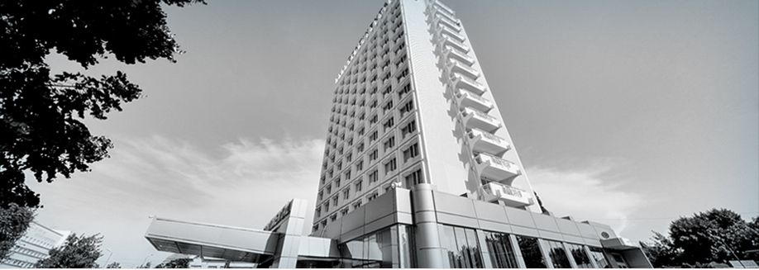
Hotel Timisoara – 4*
single room 4 star : 100 € (with breakfast / night)
double room 4 star : 110 € (with breakfast / night)
To book rooms in this hotel please contact the hotel directly at
office@hoteltimisoara.ro
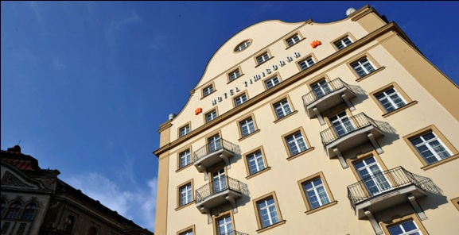
Hotel Savoy – 4*
single room – 40€ (without breakfast), 50 € (with breakfast) / night / room
double room – 50€ (without breakfast), 66 € (with breakfast) / night / room / double occupancy
To book rooms in this hotel please contact the hotel directly at contact@hotelsavoytimisoara.ro .
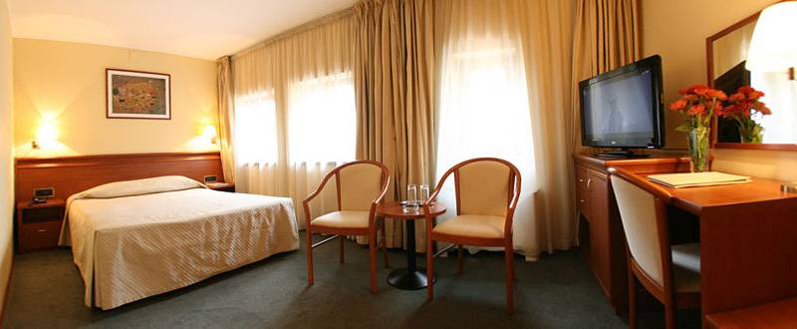
Hotel Perla
3* and 4* – various prices
To book rooms in this hotel please contact the hotel directly at
office@hotelperla.ro
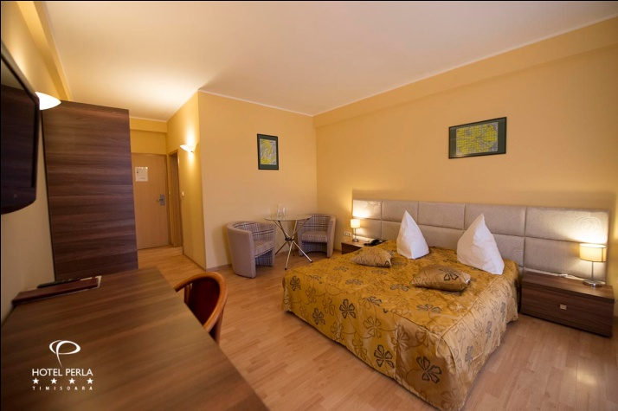

CP1 (Casa Politehnicii 1) –
This hotel belongs to the Politehnica University and is a basic 3*star one, with a great position, just in the main Square.
Single Room – 100 Ron (~20 Euros)/room
Double Room – 150 Ron (~30 Euros)/room
Breakfast + Free Wi-Fi included. There are no elevator facilities.
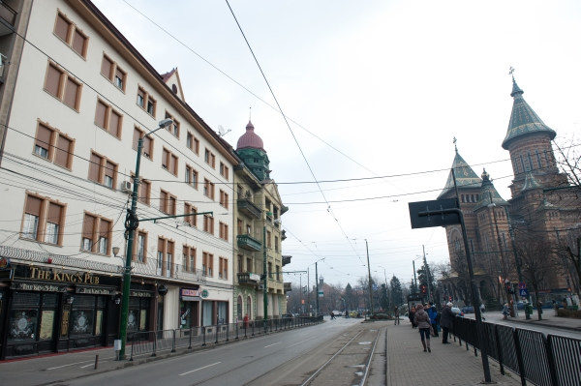

Casa Poli 2 (recommended, see conference web site)
When you book please mention you are a GLOREP2018 conference participant. All dinners are served in the restaurant of this hotel.
The university has another hotel, CP2, a plus 3*star hotel. It is a new refurbished hotel, in the city center at about 10-15 minutes walking from the conference halls.
Single Room -160 Ron (~32 Euros)/room
Double Room -200 Ron (~40 Euros)/room
Free Wi-Fi included. Extra breakfast cost is 13 Ron/person/meal (~3 Euros). There are no elevator facilities.
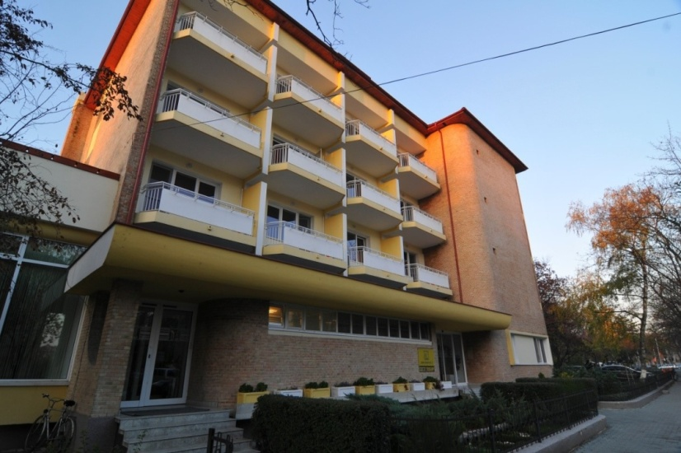
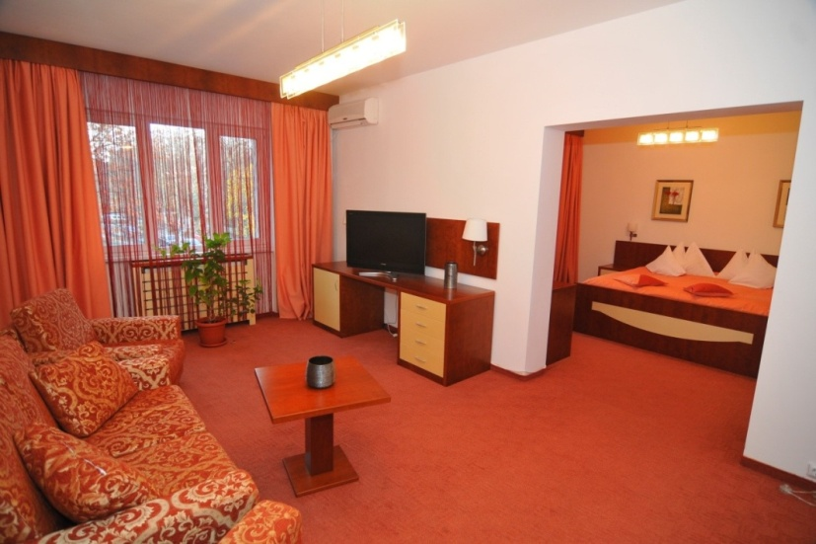
Other hotels in the area can be booked online.

